**Facebook Windows Desktop App – Ex01**

Use Case Diagram:

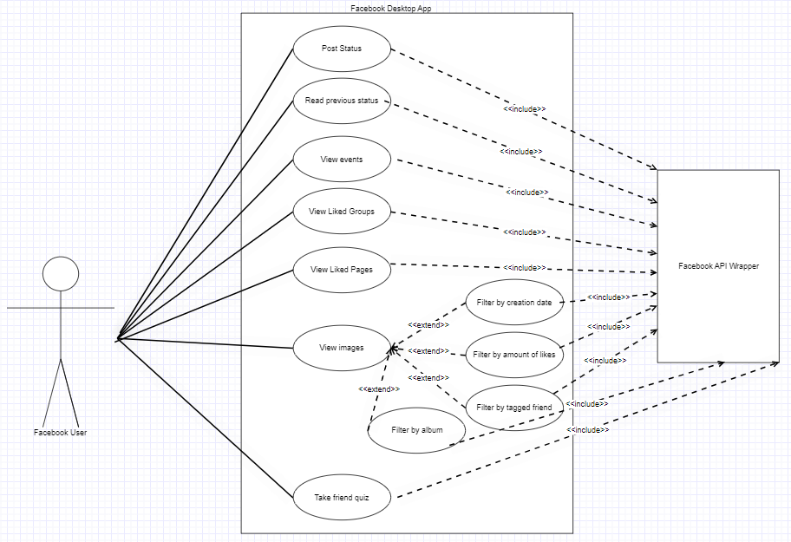

Sequence Diagram – Friends Quiz:

